Pulse Generator

Our task is to make a a sequence recognizer which is of 01 i.e we have to make output 1 every time when input change from 0 to 1. Fro example analyze the following input and output:
input: 1110100011110111
output: 0000100010000100.
Now lets make a state machine for this task
we are assuming that the input is 0 from the stat. So we have to make input 1 after 0. and make output
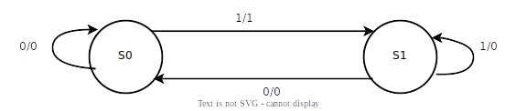
zero on every other case.

Wave:
The output wave we get after applying this pulse generator mealy machine is
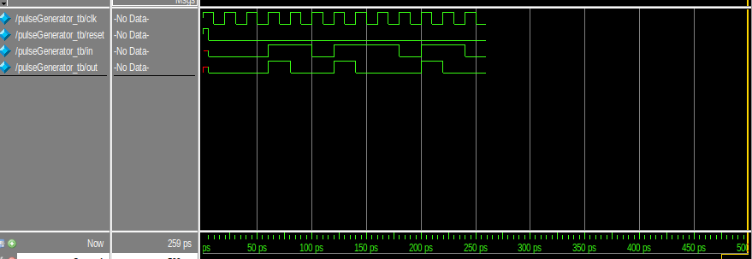
Explanation:
The wave showed the clock, reset, input and output. The output is input is changing from 0 to 1 at last line.

